PATIENT INTAKE FORM

PLEASE COMPLETE AS APPLICABLE
Today’s Date (D/M/Y):
Full Name: (Last): (First): (Middle):
Date Of Birth (D/M/Y): Gender: female male
Phone Number: (H): (W): (C):
Physical Address:
P.O.Box:
Postal Code:
Email:
Guardian Name( only for minors):
Guardian DOB:
Employer/School Name:
Referred By:
Emergency Contact:
Relationship To The Patient:
Contact Details:
Preferred Pharmacy:
INSURANCE INFORMATION
Insurance Provider:
Certificate Number:
Group Number:

QUESTIONS ABOUT YOUR CURRENT PROBLEM:
1. When did your pain / condition first occur?
2. How did it happen?
Please check()one: Accident at work Accident at home Following Surgery
Surgery Other Accident
Following Illness Pain/condition just began
3. Have you ever had this pain /condition before? If yes, explain:

4. What makes your pain / condition worse:
5. What makes your better?

ASSESMENT:

Mark the areas on the body where you feel the described sensations using the following marking:
(Note: If you are filling out this form online, you cannot draw on this form. Please verbally describe WHERE the pain is on this line

Burning: / / Achiness: I I
Numbness: VV Pins/needles/Itchiness: O O
Pain: X X Stabbing: ZZ
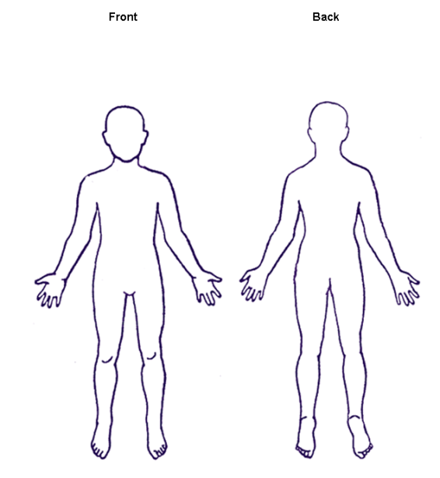

DIAGNOSTIC TESTS DONE FOR YOUR PROBLEM:

Test When done? Facility Name Findings

X-Ray ( what body part?)
CT(CAT Scan)
MRI
Mammogram
EMG
Ultrasound

MEDICATIONS:

Please list all the medications you currently take for any reason (including non-prescription drugs):
Drug Name Drug Dose How often? Pain Meds Only-Helps?
yes no
yes no
yes no
yes no
yes no
yes no
yes no
yes no

PLEASE LIST ALL KNOWN ALLERGIES:

PAST MEDICAL/SURGICAL HISTORY:

FAMILIY AND SOCIAL HISTORY:

- Please note that Co-pays are collected at the time of visit.
- I authorize the release of any medical records or other information necessary to process this claim. I understand that all medical records will be stored on a secure, encrypted server for 7 years. I understand that my data is collected, stored and shared as needed and is handled in compliance with the data protection law.
- I understand that all treatment fees will be billed directly to my insurance company provider. Please note that we charge the SHIC customary health insurance charges.
- I authorize NovoClinic to verify my health insurance benefits. I will be responsible for all co-pays/co-insurance and deductibles that may apply.
- I understand that I will be responsible for all rejected amounts billed to my insurance provider for services rendered by the medical practitioners of NovoClinic.
- I understand that any amounts outstanding for more than 90 days will be send for debt collection through the appropriate channels.
- I grant permission for licensed medical practitioners at NovoClinic to perform such examinations and medical treatments as may be professionally deemed necessary or advisable for appropriate evaluation and treatment of my condition. I understand that I will be given all available pertinent information prior to treatment being rendered. I will be given the opportunity to ask questions and to have them answered to my satisfaction.
- I understand that I may decline treatment at any time.

SIGNATURE ________________________ DATE_______________

